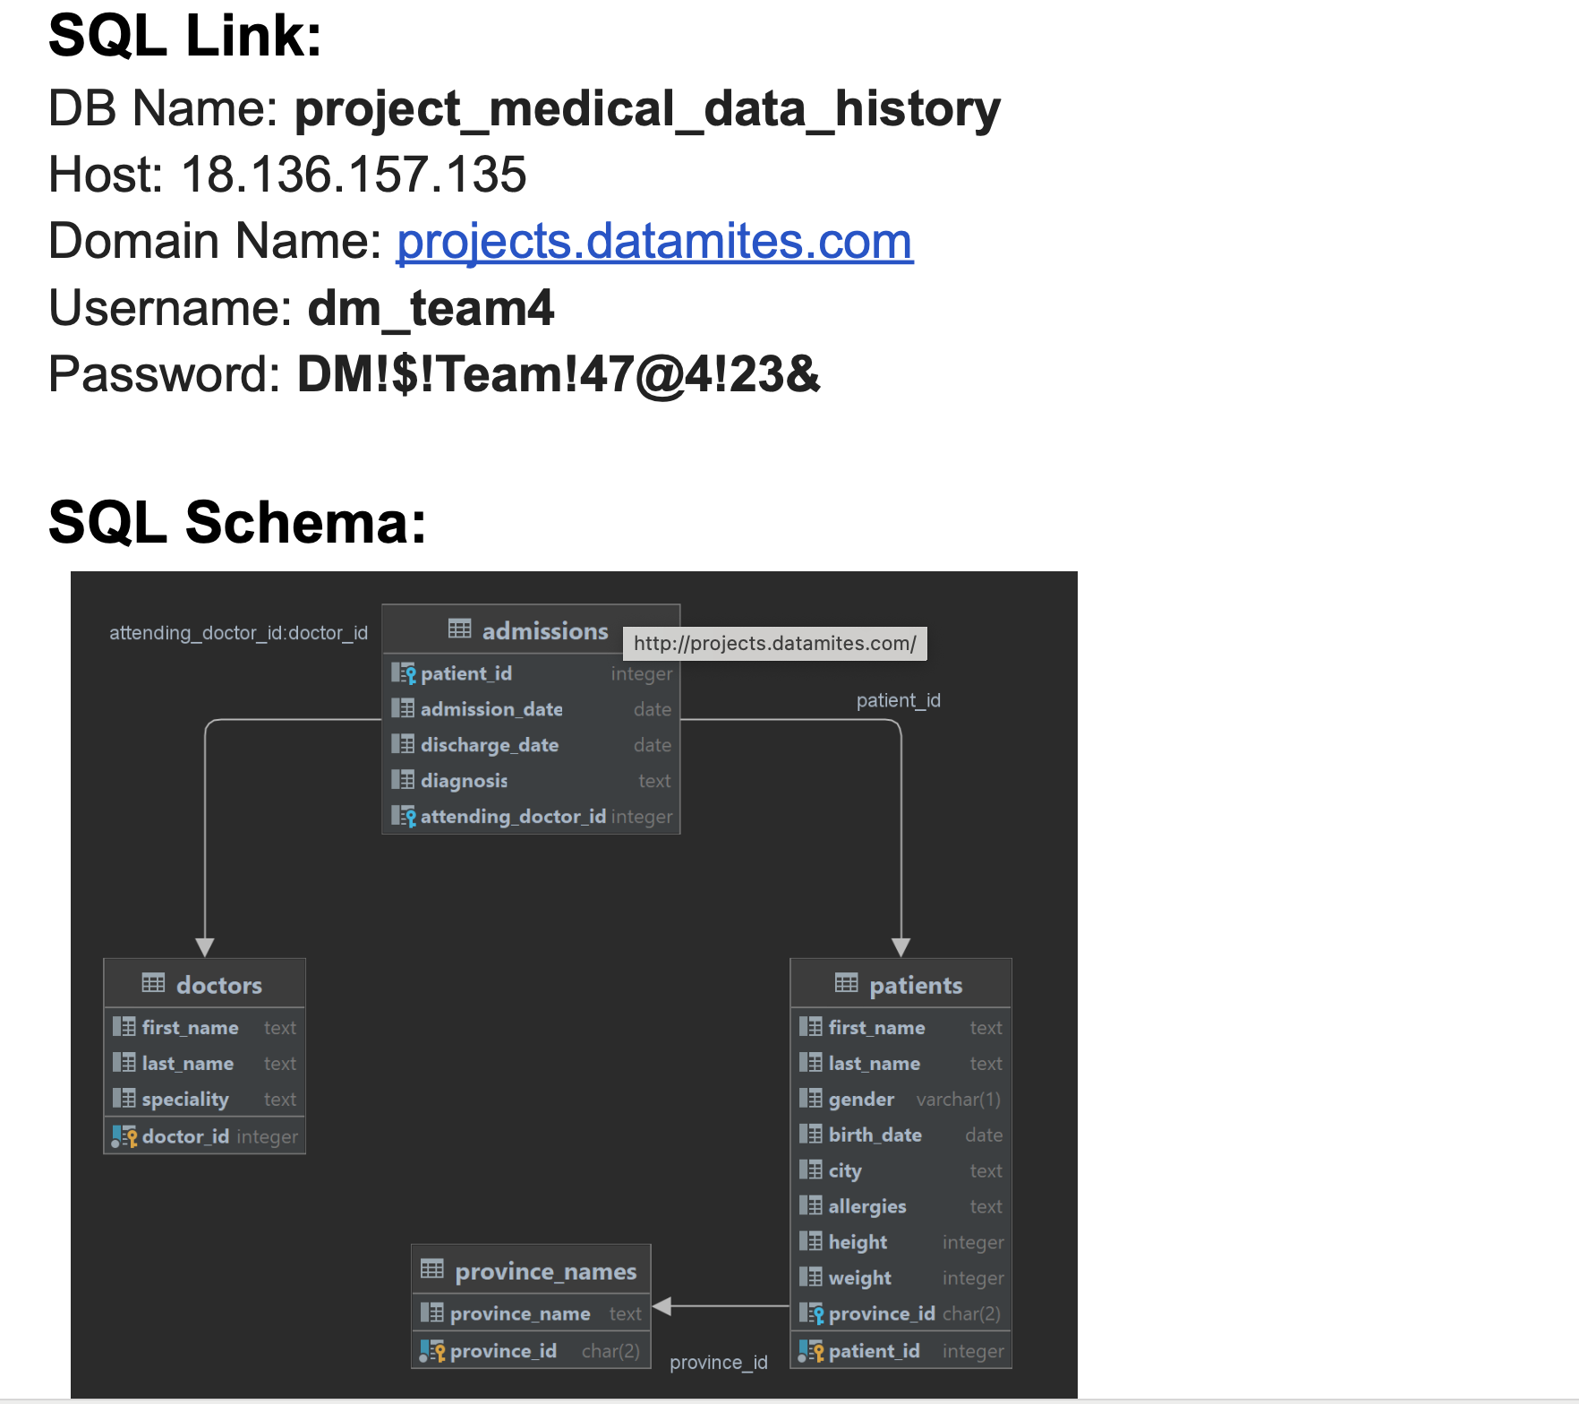
Docker mysql Client Terminal:
>docker run -it --rm mysql:latest mysql \
-h 18.136.157.135 -P 3306 -u dm_team4 -p
Enter password:
Welcome to the MySQL monitor. Commands end with ; or \g.
Your MySQL connection id is 447
Server version: 5.7.31 MySQL Community Server (GPL)

Copyright (c) 2000, 2025, Oracle and/or its affiliates.

Oracle is a registered trademark of Oracle Corporation and/or its
affiliates. Other names may be trademarks of their respective
owners.

Type 'help;' or '\h' for help. Type '\c' to clear the current input statement.

mysql>

1.Show first name, last name, and gender of patients whose gender is ‘M’.
SELECT first_name, last_name, gender
FROM patients
WHERE gender = 'M';

2.Show first name and last name of patients who do not have allergies.
SELECT first_name, last_name
FROM patients
WHERE allergies IS NULL;
3.Show first name of patients that start with the letter ‘C’.
SELECT first_name
FROM patients
WHERE first_name LIKE 'C%';
4.Show first name and last name of patients that weight within the range of 100 to 120 (inclusive).
SELECT first_name, last_name
FROM patients
WHERE weight >= 100 AND weight <= 120;

5.Update the patients table for the allergies column. If the patient’s allergies is null then replace it with ‘NKA’.
UPDATE patients
SET allergies = 'NKA'
WHERE allergies IS NULL;
ERROR 1142 (42000): UPDATE command denied to user 'dm_team4'@'101.0.62.133' for table 'patients'
6.Show first name and last name concatenated into one column to show their full name.
SELECT CONCAT(first_name, ' ', last_name) AS full_name FROM patients;

7.Show first name, last name, and the full province name of each patient.
SELECT pat.first_name,
pat.last_name,
pro.province_name
FROM patients pat
JOIN province_names pro
ON pat.province_id = pro.province_id;
8.Show how many patients have a birth_date with 2010 as the birth year.
SELECT
EXTRACT(YEAR FROM birth_date) AS year_val,
COUNT(*) AS patient_count
FROM patients
WHERE EXTRACT(YEAR FROM birth_date) = 2010
GROUP BY year_val;
9.Show the first_name, last_name, and height of the patient with the greatest height.
SELECT first_name, last_name, height FROM patients
ORDER BY height DESC
LIMIT 1;
10.Show all columns for patients who have one of the following patient_ids: 1, 45, 534, 879, 1000.
SELECT * FROM patients
WHERE patient_id IN (1, 45, 534, 879, 1000);
11.Show the total number of admissions.
SELECT COUNT(*) AS total_admissions FROM admissions;

12.Show all the columns from admissions where the patient was admitted and discharged on the same day.
SELECT * FROM admissions
WHERE admission_date = discharge_date;
13.Show the total number of admissions for patient_id 579.
SELECT COUNT(*) AS total_admissions FROM admissions
WHERE patient_id = 579;
14. Based on the cities that our patients live in, show unique cities that are in province_id 'NS'.
SELECT DISTINCT pat.city FROM patients pat
JOIN province_names pro
ON pat.province_id = pro.province_id
WHERE pro.province_id = 'NS';
15. Write a query to find the first_name, last_name, and birth_date of patients who have height more than 160 and weight more than 70.
SELECT first_name, last_name, birth_date
FROM patients
WHERE height > 160 AND weight > 70;
16. Show unique birth years from patients and order them by ascending.
SELECT DISTINCT birth_date FROM patients
ORDER BY birth_date ASC;
17. Show unique first names from the patients table which only occurs once in the list.
SELECT first_name FROM patients
GROUP BY first_name
HAVING COUNT(*) = 1;

18. Show patient_id and first_name from patients where their first_name starts and ends with 's' and is at least 6 characters long.
SELECT first_name FROM patients
WHERE first_name LIKE 's%s'
AND LENGTH(first_name) >= 6;
19. Show patient_id, first_name, last_name from patients whose diagnosis is 'Dementia'. (Primary diagnosis is stored in the admissions table)
SELECT
pat.patient_id,
pat.first_name,
pat.last_name
FROM patients pat
JOIN admissions admi
ON pat.patient_id = admi.patient_id
WHERE admi.diagnosis = 'Dementia';
20. Display every patient’s first_name. Order the list by the length of each name and then by alphabetically.
SELECT first_name FROM patients
ORDER BY LENGTH(first_name), first_name ASC;
21. Show the total number of male patients and the total number of female patients in the patients table. Display the two results in the same row.
SELECT
COUNT(CASE WHEN gender = 'M' THEN 1 END) AS male_count,
COUNT(CASE WHEN gender = 'F' THEN 1 END) AS female_count
FROM patients;

22. Show the total number of male patients and the total number of female patients in the patients table. Display the two results in the same row.
SELECT
COUNT(CASE WHEN gender = 'M' THEN 1 END) AS male_count,
COUNT(CASE WHEN gender = 'F' THEN 1 END) AS female_count
FROM patients;
23. Show patient_id, diagnosis from admissions. Find patients admitted multiple times for the same diagnosis.
SELECT patient_id,diagnosis,COUNT(*) as admission_count FROM admissions
GROUP BY patient_id, diagnosis
HAVING COUNT(*) > 1;
24. Show the city and the total number of patients in the city. Order from most to least patients and then by city name ascending.
SELECT city, count(patient_id) AS total_patients FROM patients
GROUP BY city
ORDER BY total_patients DESC, city ASC;
25. Show first_name, last_name and role of every person that is either patient or doctor. The roles are either "Patient" or "Doctor".
select first_name,last_name,'patient' as role from patients
union all
select first_name,last_name,'doctor' as role from doctors;

26. Show all allergies ordered by popularity. Remove NULL values from the query.
SELECT allergies,COUNT(*) AS allergens_count FROM patients
WHERE allergies IS NOT NULL
GROUP BY allergies
ORDER BY allergens_count DESC;
27. Show all patient’s first_name, last_name, and birth_date who were born in the 1970s decade. Sort the list starting from the earliest birth_date.
SELECT first_name,last_name,EXTRACT(YEAR FROM birth_date) AS year_val FROM patients
WHERE EXTRACT(YEAR FROM birth_date) BETWEEN 1970 AND 1979;
28. We want to display each patient’s full name in a single column. Their last_name in all UPPER letters must appear first, then first_name in all lower case letters. Separate the last_name and first_name with a comma. Order the list by the first_name in descending order.
select concat(upper(last_name),",",first_name) as patient_formatnames from patients
order by patient_formatnames desc;
30. Show the province_id(s), sum of height; where the total sum of its patient’s height is greater than or equal to 7,000.
SELECT province_id,SUM(height) AS patient_height FROM patients
GROUP BY province_id
HAVING SUM(height) >= 7000;
30. Show the difference between the largest weight and smallest weight for patients with the last name 'Maroni'.
SELECT MAX(weight) - MIN(weight) AS weight_difference
FROM patients
WHERE last_name = 'Maroni';
31. Show all of the days of the month (1–31) and how many admission_dates occurred on that day. Sort by the day with most admissions to least admissions.
SELECT EXTRACT(DAY FROM admission_date) AS admission_day,COUNT(*) AS total_admissions
FROM admissions
GROUP BY admission_day
ORDER BY total_admissions DESC;

32. Show all of the patients grouped into weight groups. Show the total number of patients in each weight group. Order the list by the weight group descending.
SELECT
CASE
WHEN weight BETWEEN 1 AND 9 THEN '1-9'
WHEN weight BETWEEN 10 AND 19 THEN '10-19'
WHEN weight BETWEEN 20 AND 29 THEN '20-29'
WHEN weight BETWEEN 30 AND 39 THEN '30-39'
WHEN weight BETWEEN 40 AND 49 THEN '40-49'
WHEN weight BETWEEN 50 AND 59 THEN '50-59'
WHEN weight BETWEEN 60 AND 69 THEN '60-69'
WHEN weight BETWEEN 70 AND 79 THEN '70-79'
WHEN weight BETWEEN 80 AND 89 THEN '80-89'
WHEN weight BETWEEN 90 AND 99 THEN '90-99'
WHEN weight BETWEEN 100 AND 109 THEN '100-109'
WHEN weight BETWEEN 110 AND 119 THEN '110-119'
WHEN weight BETWEEN 120 AND 129 THEN '120-129'
WHEN weight BETWEEN 130 AND 139 THEN '130-139'
WHEN weight BETWEEN 140 AND 142 THEN '140-142'
ELSE 'Other'
END AS weight_group,
COUNT(*) AS patient_count
FROM patients
GROUP BY weight_group
ORDER BY weight_group;
33. Show patient_id, weight, height, isObese from the patients table. Display isObese as a boolean 0 or 1. Obese is defined as weight(kg) / (height(m)).
.SELECT patient_id,weight,height,
CASE
WHEN (weight / (height / 100)) >= 30 THEN 1 ELSE 0 END AS isObese FROM patients;
34. Show patient_id, first_name, last_name, and attending doctor’s specialty. Show only the patients who have a diagnosis as 'Epilepsy' and the doctor’s first name is 'Lisa'.
(Check patients, admissions, and doctors tables for required information.)
SELECT
pat.patient_id,
pat.first_name AS patient_first_name,
pat.last_name AS patient_last_name,
admi.diagnosis AS admissions_diagnosis,
doc.specialty AS doctor_specialty,
doc.first_name AS doctor_first_name
FROM patients pat
JOIN admissions admi
ON pat.patient_id = admi.patient_id
JOIN doctors doc
ON admi.attending_doctor_id = doc.doctor_id
WHERE admi.diagnosis = 'Epilepsy'
AND doc.first_name = 'Lisa';

35. All patients who have gone through admissions can see their medical documents on our site. Those patients are given a temporary password after their first admission. Show the patient_id and temp_password.

The password must be the following, in order:
- patient id
- the numerical length of patient's last_name
- year of patient's birth_date

Select patient_id,concat(patient_id,length(last_name),extract(year from birth_date)) as temp_password from patients;

